Z

ADVANCE MANAGEMENT SYSTEM

AMS

An accounting software system designed to handle advance requests

ADVANCE MANAGEMENT SYSTEM

AMS

# About AMS

The Advance Management System is a financial accounting system designed to track and document how cash is being spent.

The system relies on a workflow mechanism that tracks and allocates responsibilities to the participants.

In order to initiate a workflow, an advance request should first be submitted. This is done by the advance requestor(Employees). Hence the request is sent to the various participants through the email system.

The system requires three complete steps to implement the **processing mode**. The three steps are:

* First approver to approve and forward the request to next step.
* Second approver to approve and forward the work flow to the cashier.
* Cahier approves to implement the **Running mode**.

Table of Contents

1 About AMS 1

2 SYSTEM REQUIRMENTS 3

3 GENERAL INFORMATION 4

3.1 System Overview 4

3.2 Organization of the Manual 5

3.3 SYSTEM SUMMARY 5

3.4 System Configuration 5

3.5 User Access Levels 6

3.6 Contingencies 7

4 GETTING STARTED 7

4.1 Installation and Logging In 7

4.2 Advance form 8

4.3 Approvers section 13

4.4 Advance Workflow 15

4.5 View Approvers 18

4.6 The Approve button 18

4.7 The Rejection form 19

4.8 The Pay slips option 19

4.9 Payment schedule calendar 20

5 Cashier Workflow 21

5.1 The New Voucher Button 22

6 TABLE OF DEFINATIONS 29

|  |  |
| --- | --- |
| SYSTEM REQUIRMENTS |  |
| operating system/Server | WINDOWS 7/8/10 |
| dot net framework/Server | MINIMUM 4.0 |
| minimum ram/Server | 2 GB |
| minimum internal memory/Server | 1 GB FREE |
| Database Server | SQL/ SQLite |
| Web browser |  |
| Microsoft-iis |  |

# GENERAL INFORMATION

The AMS system, also known as Advance Management System, is a web based system designed to run on LAN/WAN network in an intranet environment. Making the system accessible from anywhere within the organization infrastructure.

The system is configuring with a mailing mechanism that sends automated mail to various participants of the system,

The system has two security features for authenticating its users.

1. Windows authentication
2. User Authentication, through supplied user name and password.

## System Overview

.

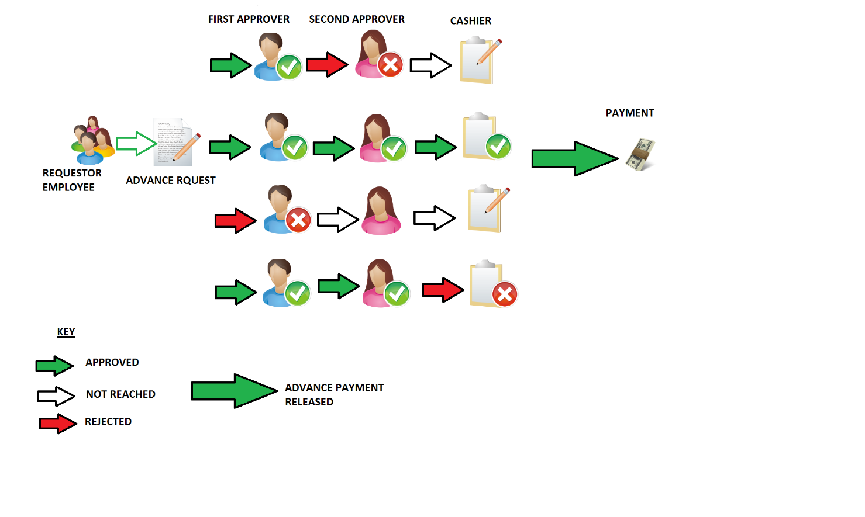

## Organization of the Manual

The user’s manual consists of five sections: **General Information, System Summary, Getting Started, Using The System**, and **Reporting**.

General Information section explains in general terms the system and the purpose for which it is intended.

System Summary section provides a general overview of the system. The summary outlines the uses of the system’s hardware and software requirements, system’s configuration, user access levels and system’s behavior in case of any contingencies.

Getting Started section explains how to get Advance Management and install it on the computer. The section presents briefly system menu.

Using The System section provides a detailed description of system functions.

## SYSTEM SUMMARY

System Summary section provides a general overview of the system. The summary outlines the uses of the system’s hardware and software requirements, system’s configuration, user access levels and system’s behavior in case of any contingencies.

## System Configuration

Advance Management System can be placed on any server that operates a windows operating system. Compatibility includes:

* Windows 7/8/ 10
* Both x86 and x64 bit operating systems.
* SQL server
* Auto syncing of data occurs when connection has finally been established with remote server.

USER REQUIREMENTS

* Web browser
* Network access
* Device independent

## User Access Levels

Only registered users have access to the system, the system has various access types, such as:

**First Approver**:

User has access to the following:

* Advance request form
* The scheduler
* The Advance approval form
* Multi Funding form
* Multi funding summary
* Reports form

**Second Approver**:

* Advance request form
* The scheduler
* The Advance approval form
* Multi Funding form
* Multi funding summary
* Multi funding returns form
* Reports form

**Accounts Cashier**

This is associated with issuing advance cash payments to employees within the organization or ministry.

* Advance request form
* The scheduler
* Voucher creation form
* Cash clearance form
* Multi funding summary
* Multi funding returns form
* Reports form

## Contingencies

The system also has an embed server that monitors login credentials and keeps an error log, this embedded server, ensures that admin rights are not abused on the system.

# GETTING STARTED

Getting Started section explains how to get Advance Management System running on the device. The section presents briefly system menu.

## Installation and Logging In

The newest installation version currently available can be downloaded from our installer, which should be installed on the server. For specific instruction on how to install application on specific device refer to device’s manual. User ID and password are delivered to user together with AMS package.

## Advance form

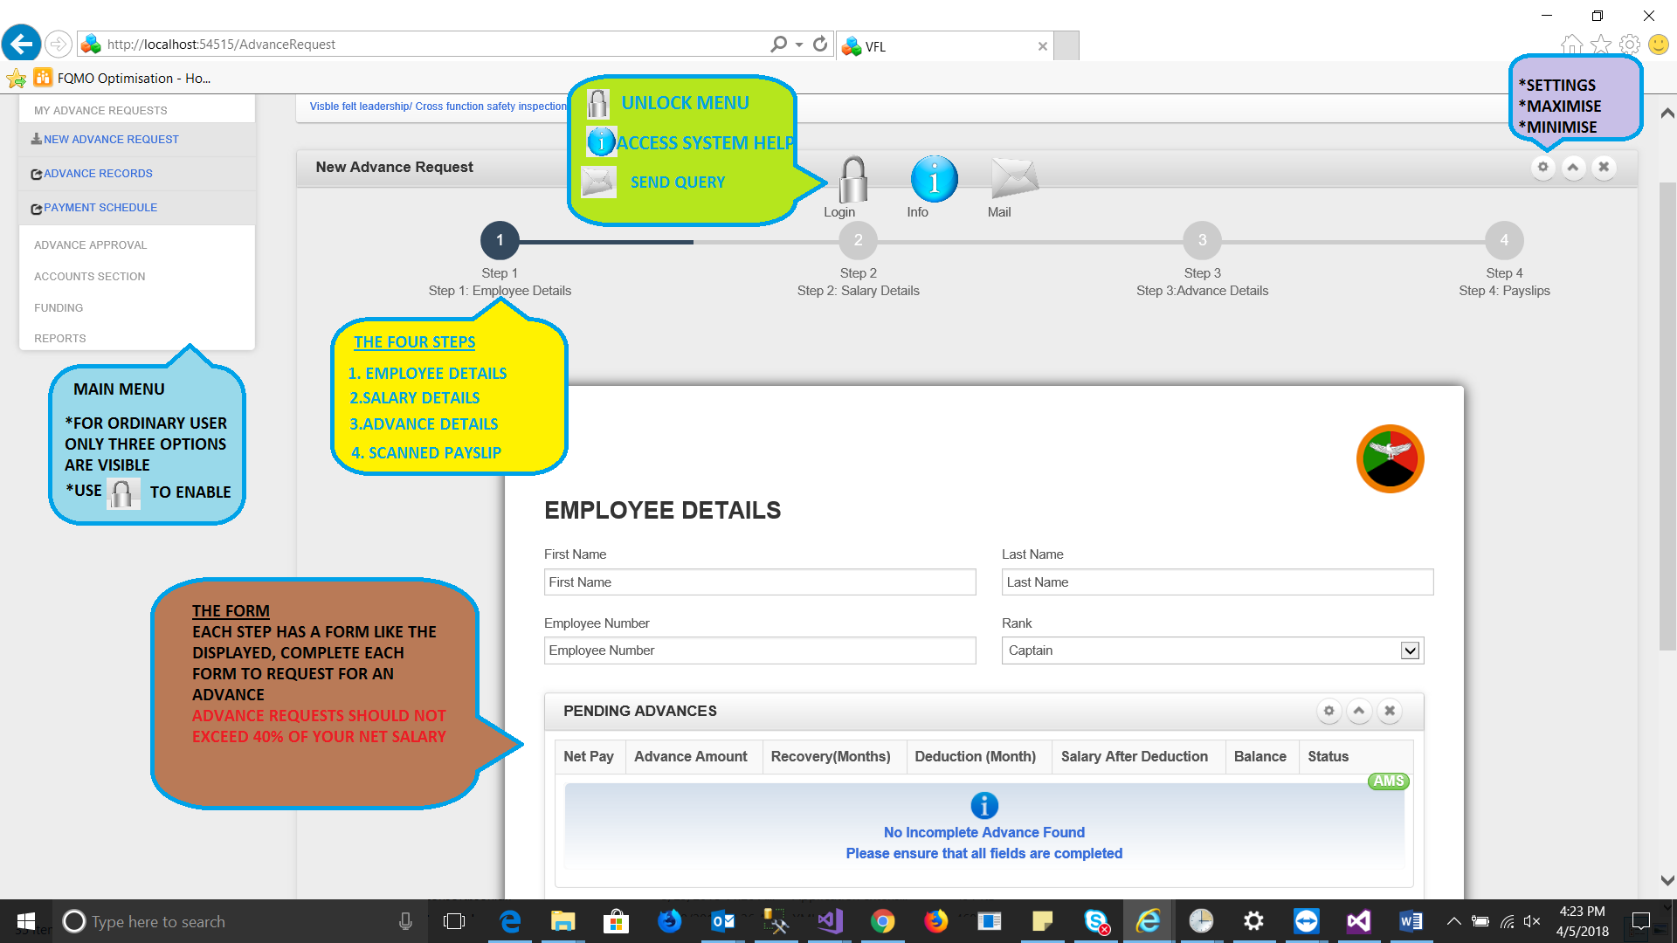The advance form is subdivided into various controls and options.

* Left Controls(Blue): The outer left control is the main menu, this is available for all user, by default certain areas of the menu are blocked.
* Top Icons(Green): The bubble bars these provide form specific features; the login icon can be used to unlock the main menu items. While the info and Mail icons, help in acquiring help from the system admin.
* The Wizard (Yellow): This has four steps used in the advance requesting process, each step has to be completed fully in order to submit the advance request.
* The form(Brown): The form holds all the input controls and display views for the system.

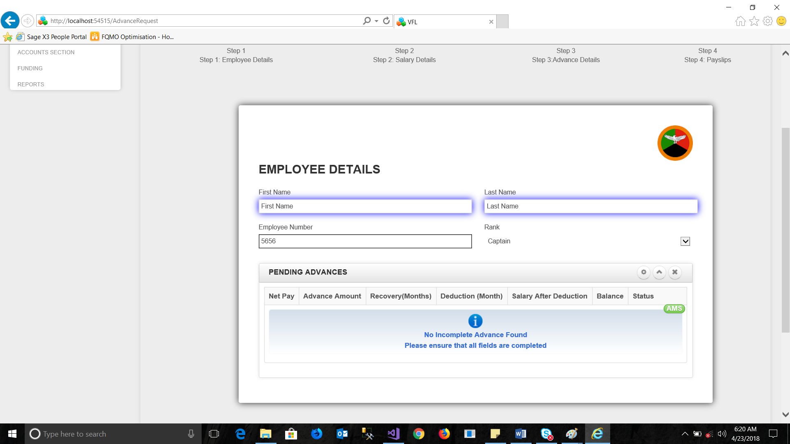

The first step is the employee details section, here employee provide a brief description of who they are, this information is then mapped to their employee number, that acts as their unique identifier.

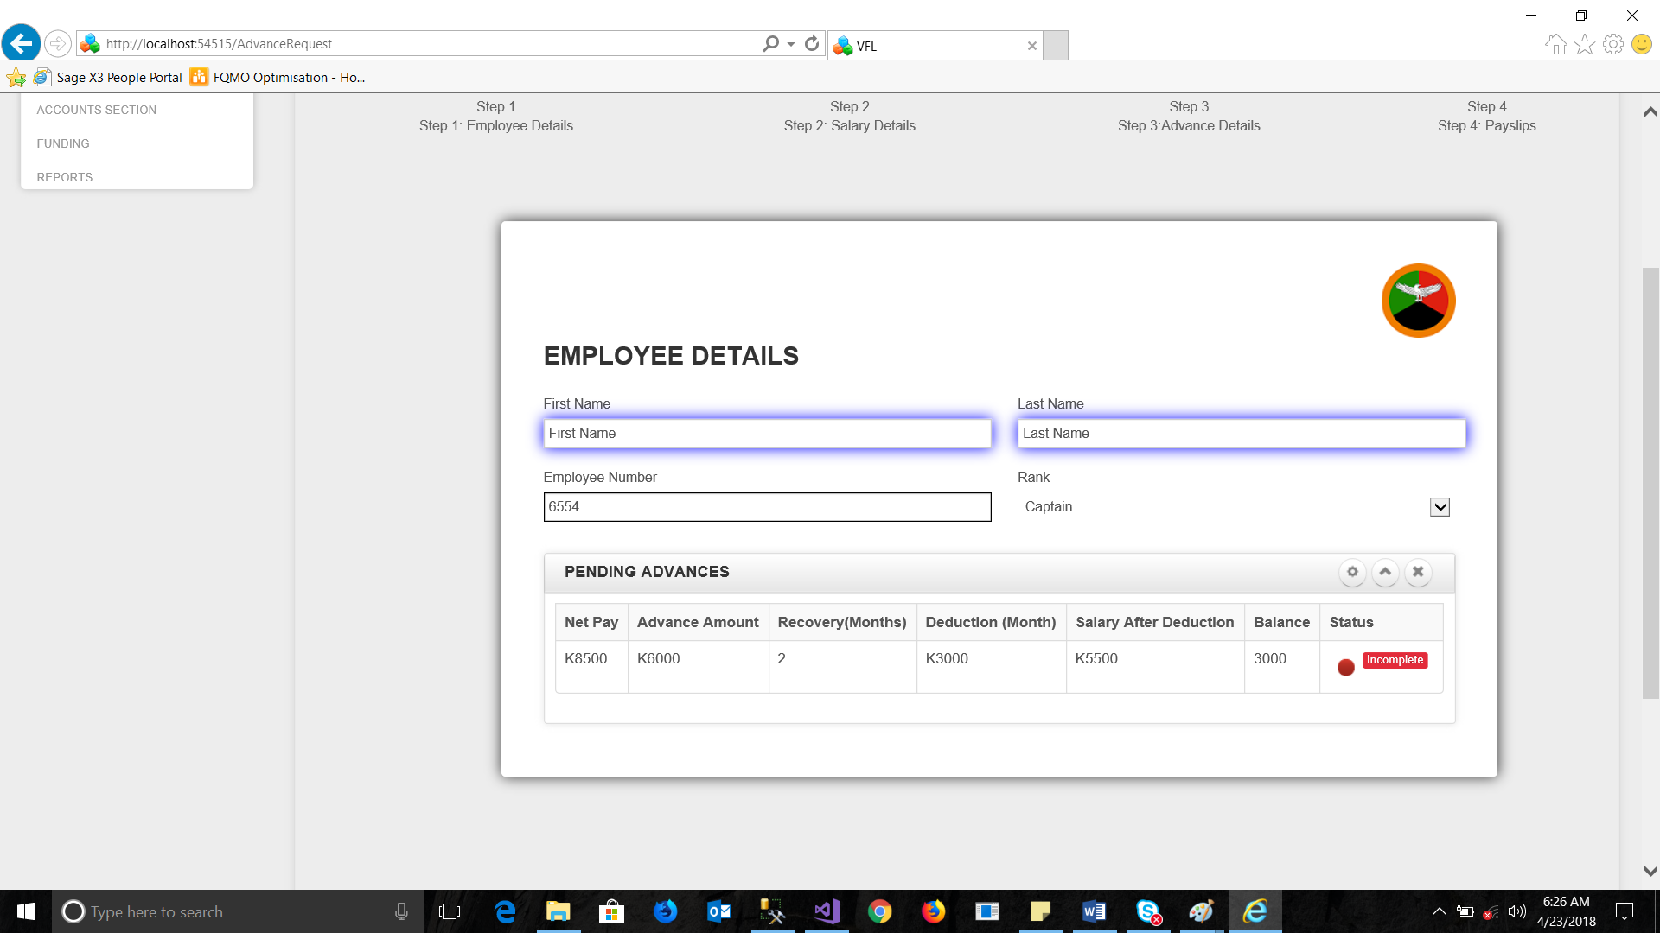

The grid auto displays data for employee with pending advances, these are labeled as incomplete in red.

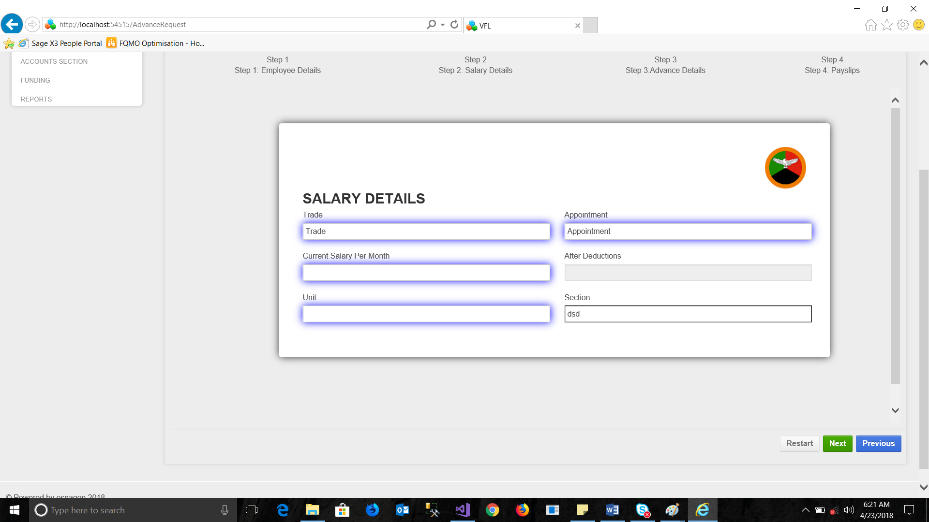

The second stage of the wizard is the salary details, this stage requires basic salary inform from the user, such as their **salary take me home (Net Pay),** few details about their position in the organization.

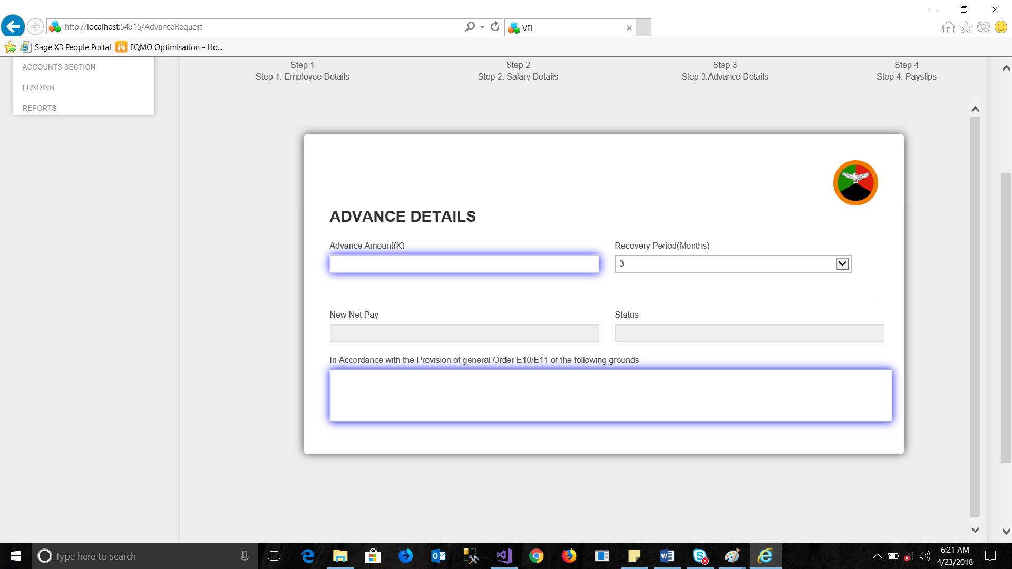

The next stage is the advance details section, this step, requires the employee to state the advance they require and duration of payment, this step happens in two stages.

* If the user falls below 40% of their **take me home** salary, this is flagged as red
* If the user lies within the required 40% range and above, the system flags this as green.

If below 40% of Take me home salary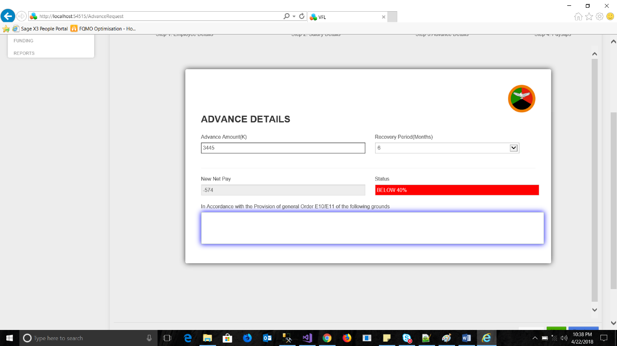

If above 40% take me home salary

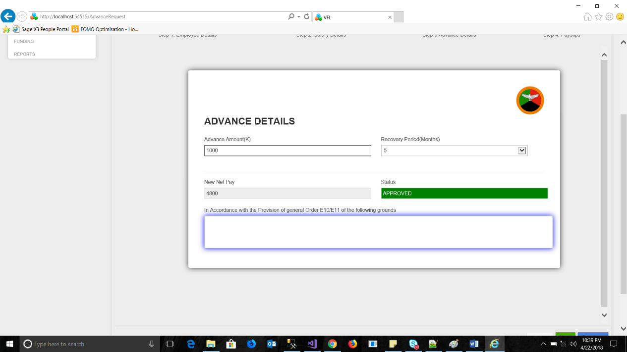

**The finale stage**

The finale stage of the wizard requires an attachment of the pay slip to be placed on the system.

The attachment should be of picture format (scanned):

Formats allowed: **png, gif, jpeg**

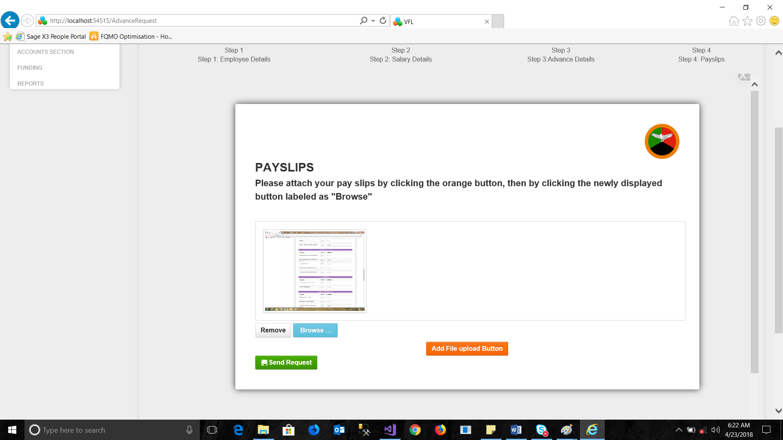

If all sections are completed the save button can be pressed to save and submit the request.

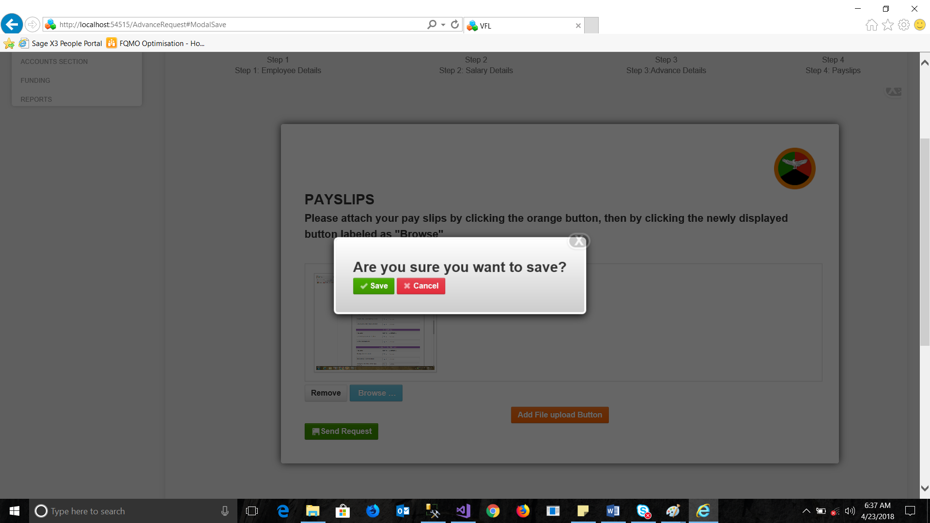

Upon selecting yes, the assign form is displayed, this window is used for allocating the request to your handler, responsible for handling your advance requests.

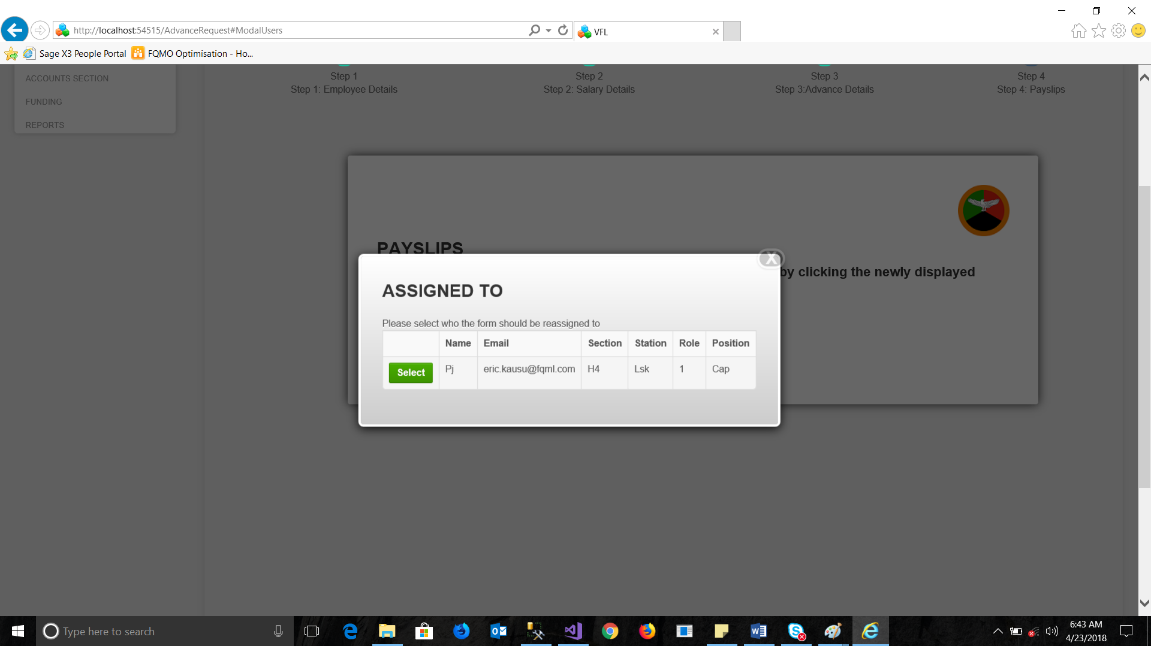

If missing forms are detected, the save failed form is displayed, this indicates the wizard stage detected with errors as on the left side and description on its right.

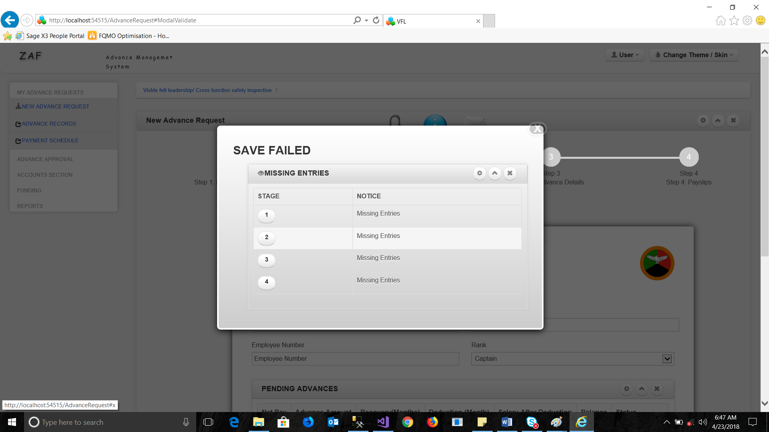

## Approvers section

The approvers form is designed for two user types, the first approver and second approver.

In order to access this form, the user needs to first unlock the form by placing their user name and password on the login icon.

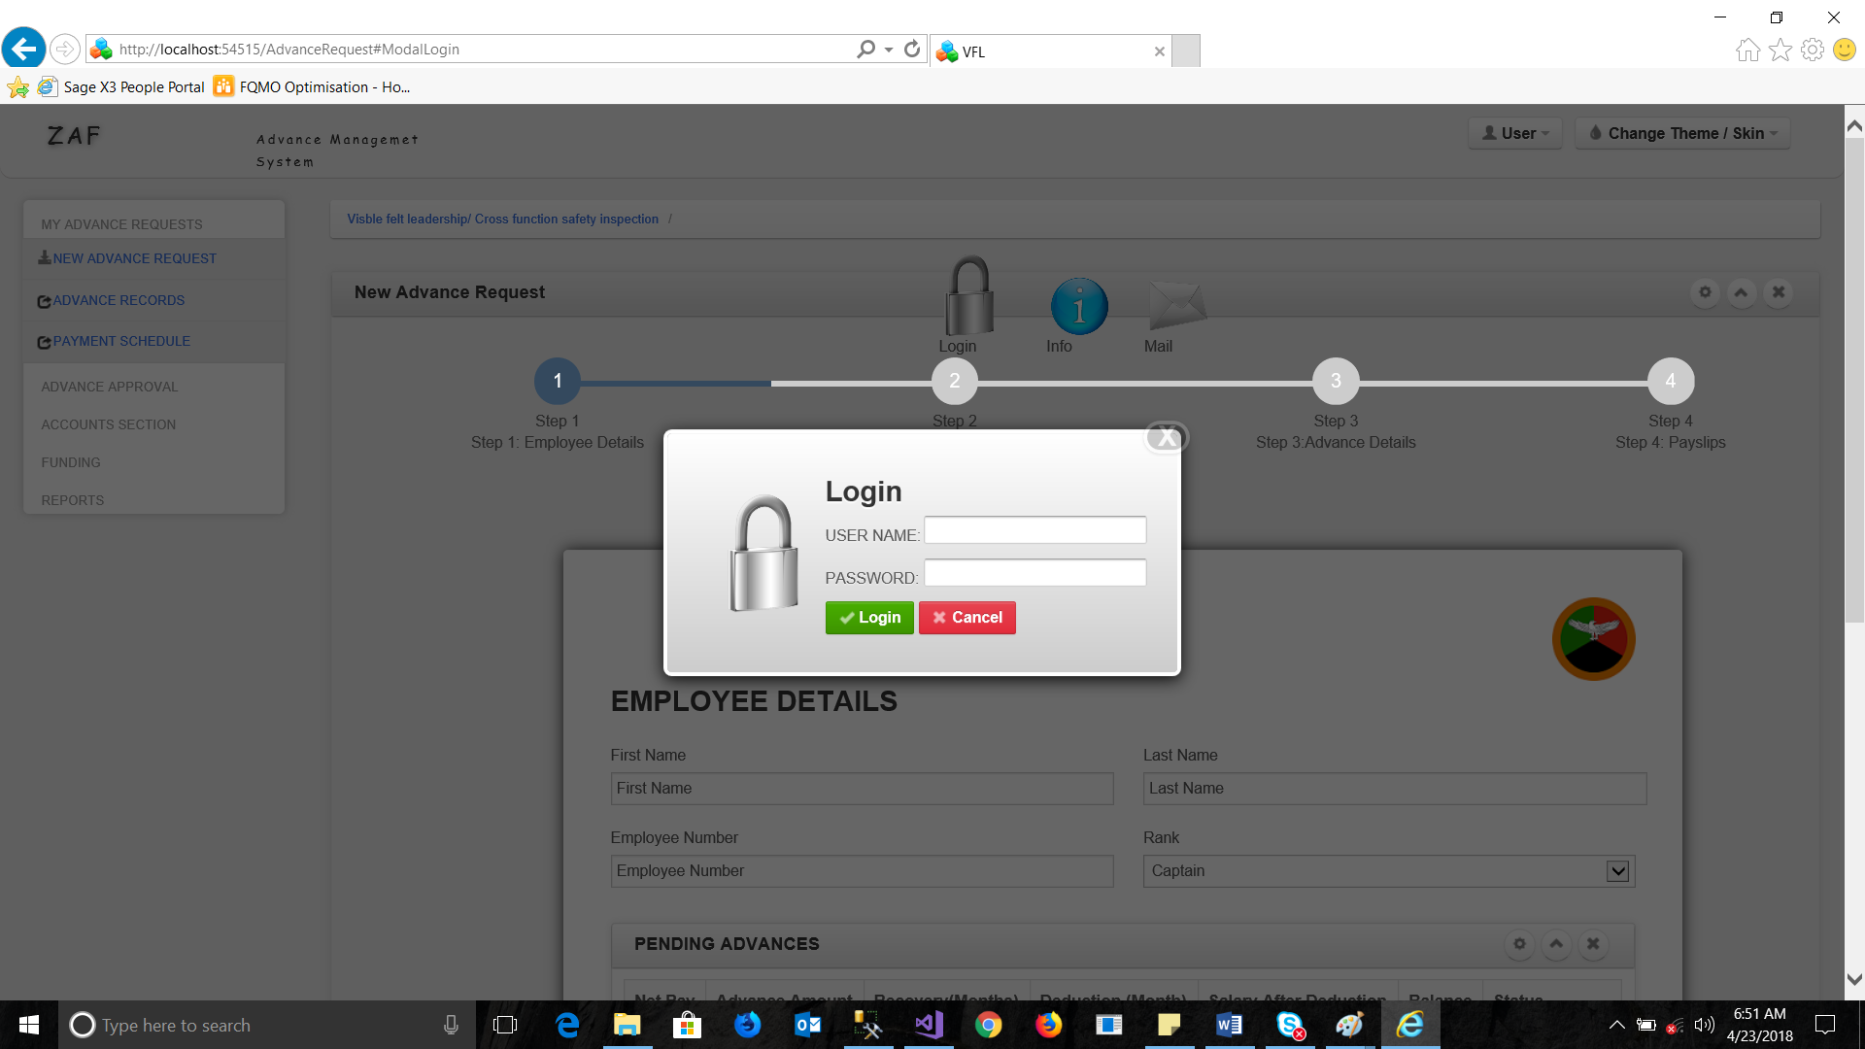

This section or mechanism is only available from the main advance request section of the system.

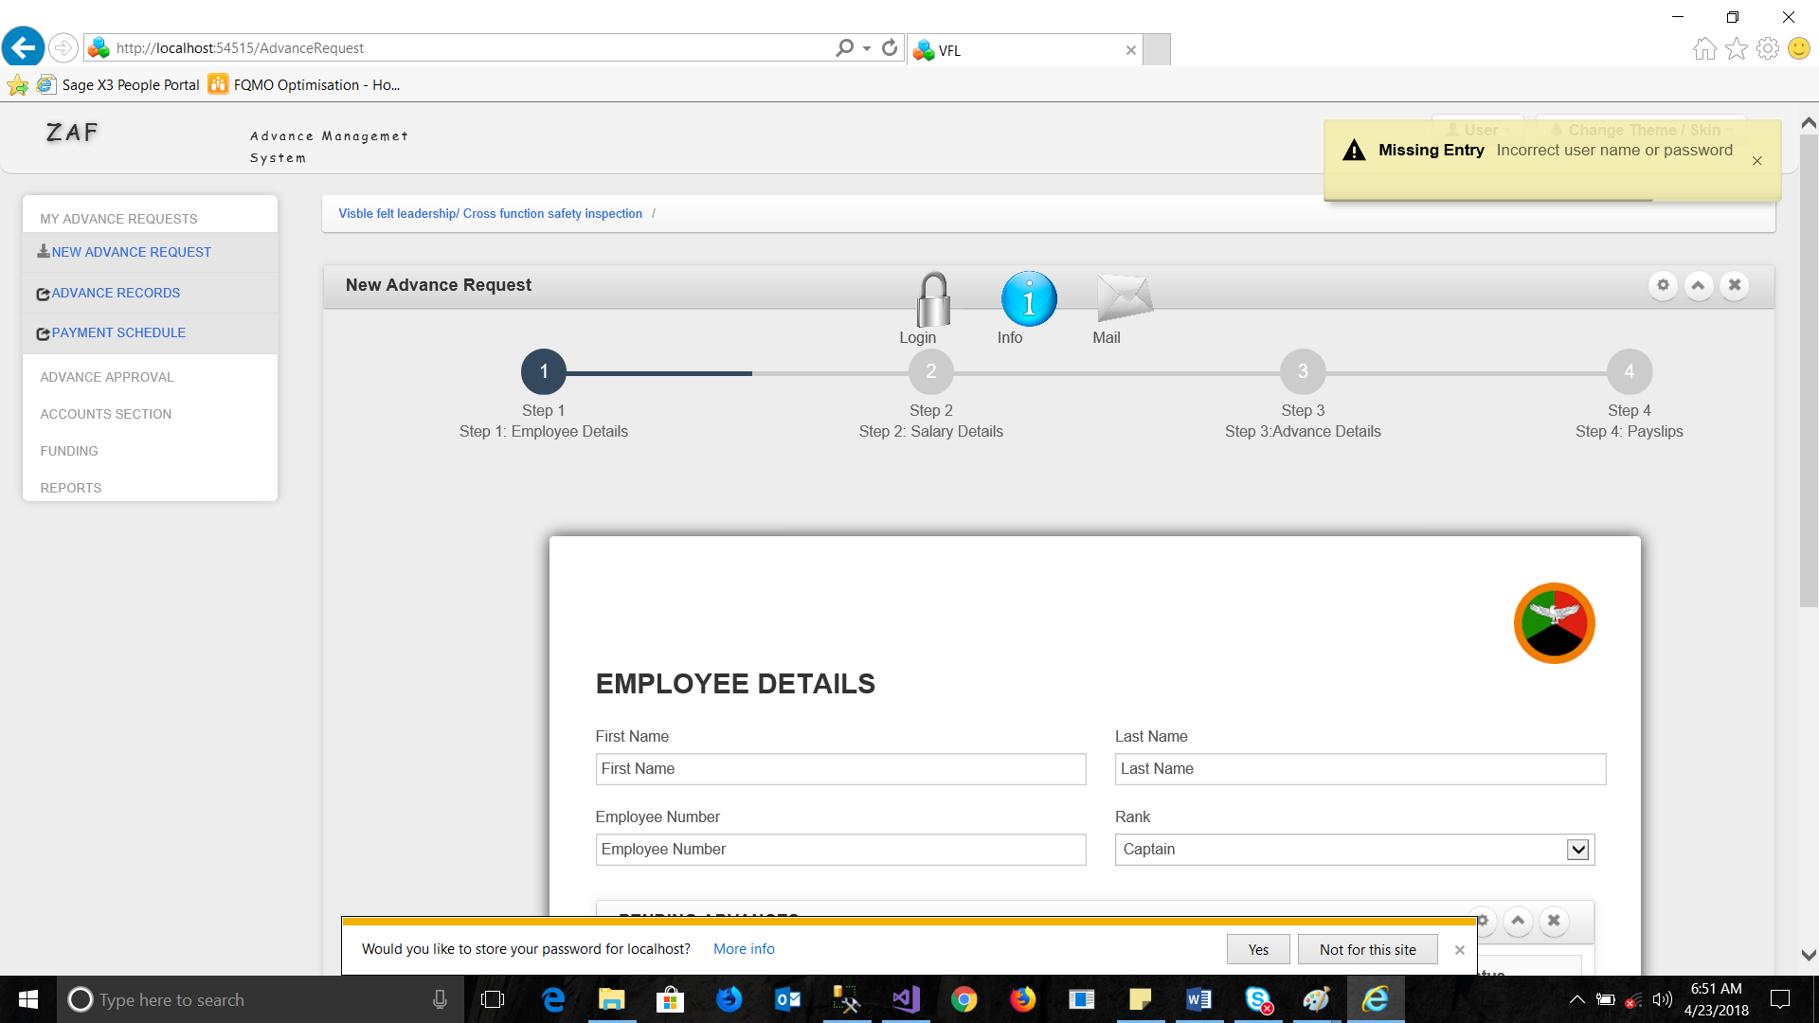

For any incorrect password or user name, a notification on the right side of the system will appear indicting the warning incorrect password error.

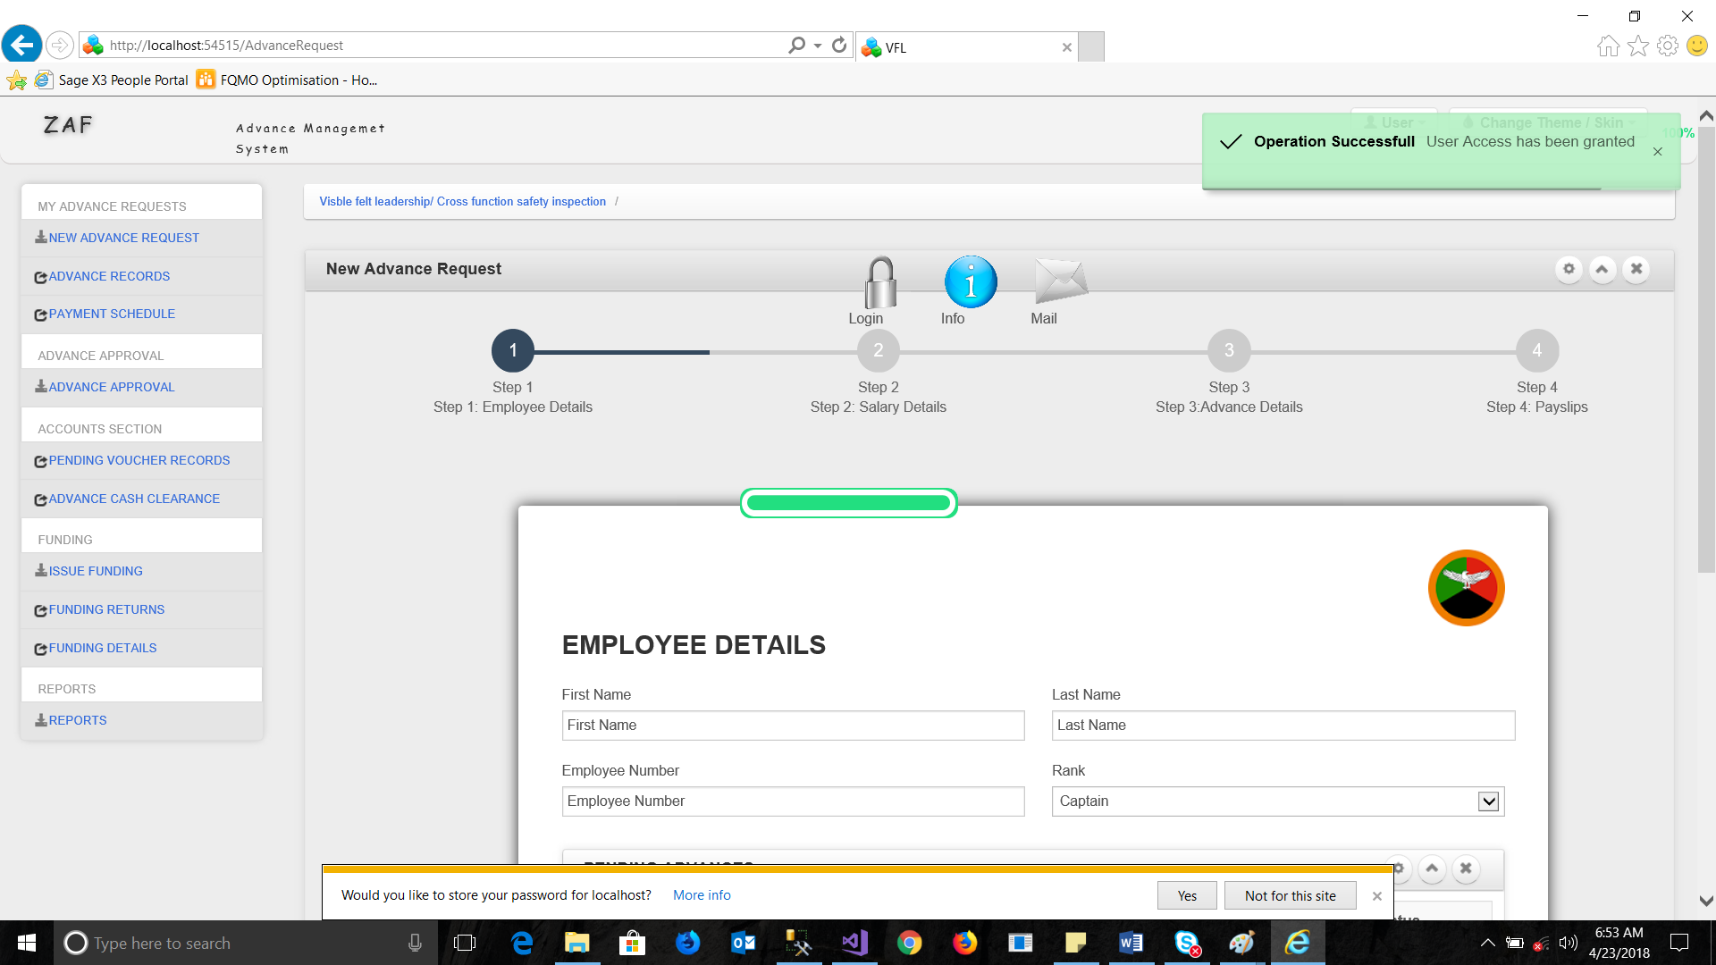

If credentials are verified successfully, the green notification will appear, and the left menu will be unlocked with extra forms.

## Advance Workflow

The advance workflow is accessible from the advance approval menu, this form by default loads the logged in user’s tasks, for approval, the form is divided into controls.

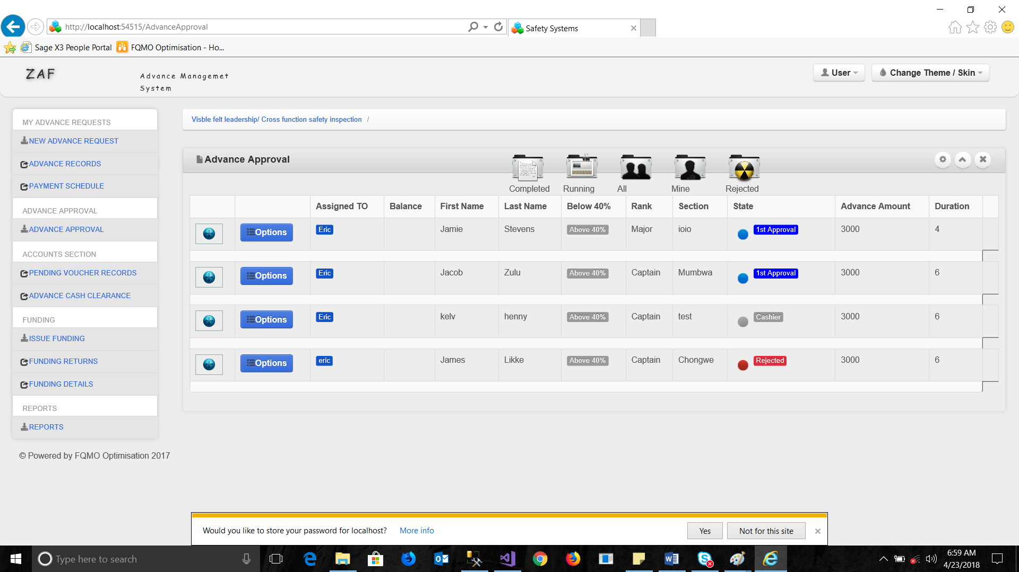

The workflow form has the following controls:

* The icons above: These provide filters of the data displayed, there are five filters: **Completed, Running, All, Mine** and **Rejected.**
* The data viewer also has features, on its first row is an expansion control (circular button) This expands and displays extra views for any particular entry.

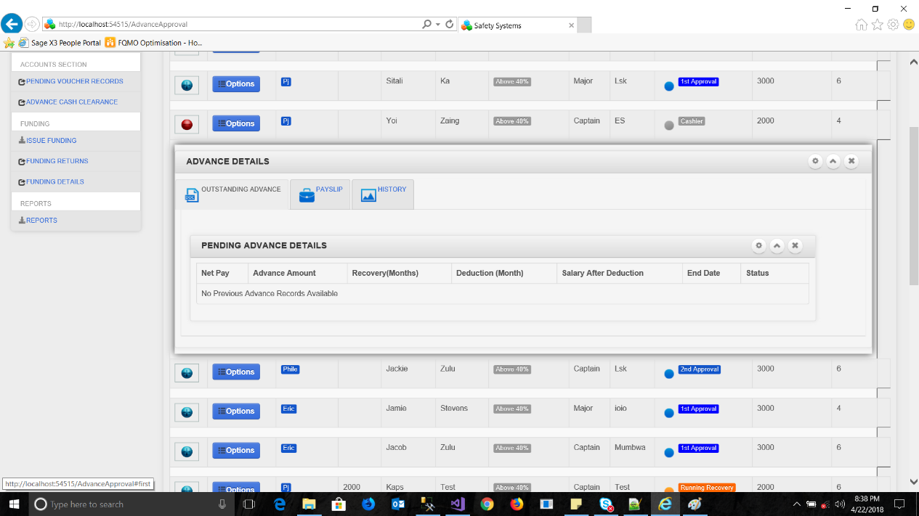

**The first tab:** This shows any outstanding pending advance the applicant may have.

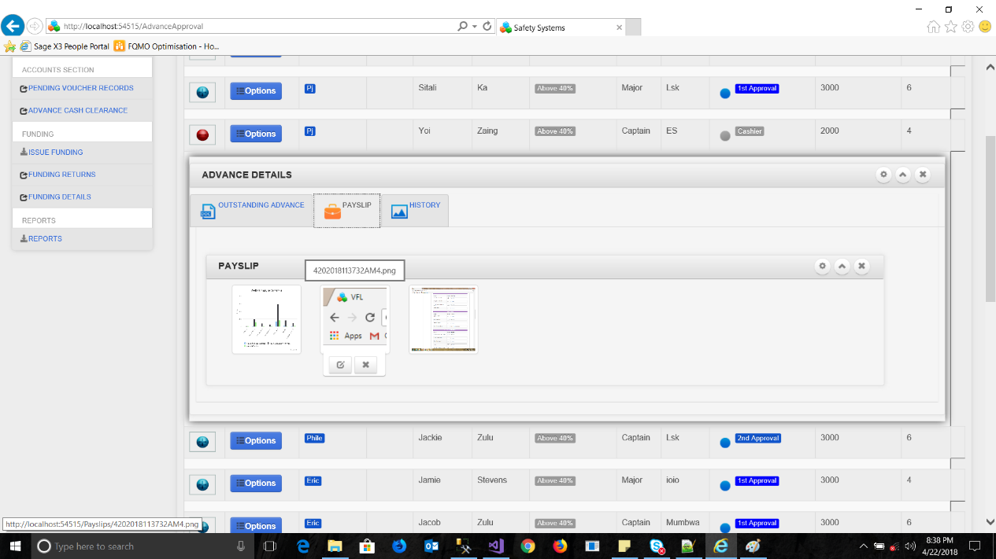

**The Second Tab:** Displays the pays lips and any documents attached to the entry.

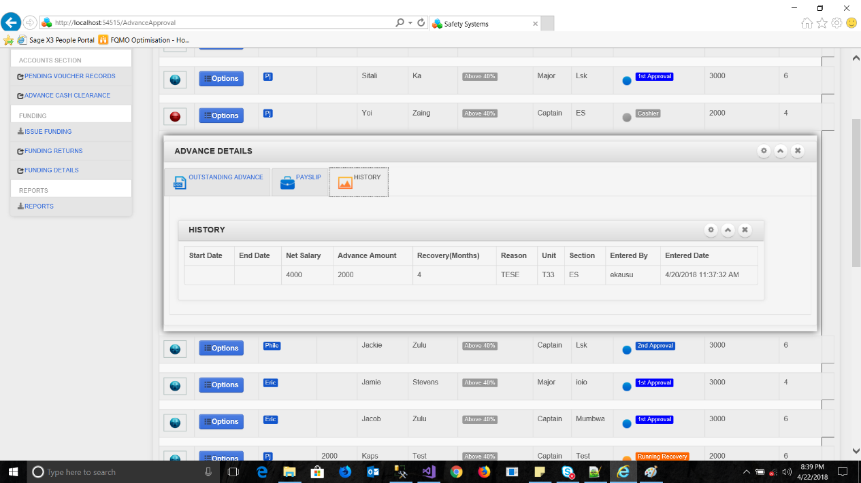

* **The options menu:** This can be displayed by clicking on the options button in the workflow section.

There are five options associated t=with this control:

1. The view approvers button
2. The view payments Calendar
3. The reassign button
4. The Approve button
5. The pays lips button.

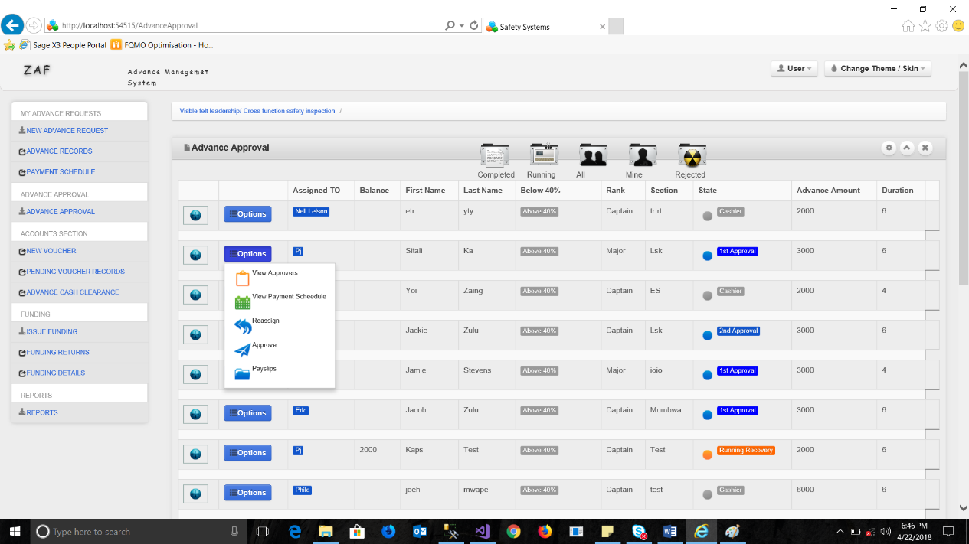

## View Approvers

This form displays the list of approvers for that particular submission.

The first potion, indicates the Date the approver approved or rejected the request.

The outcome, this indicates the type of event submitted by the approver, while approved by shows the name of the approver.

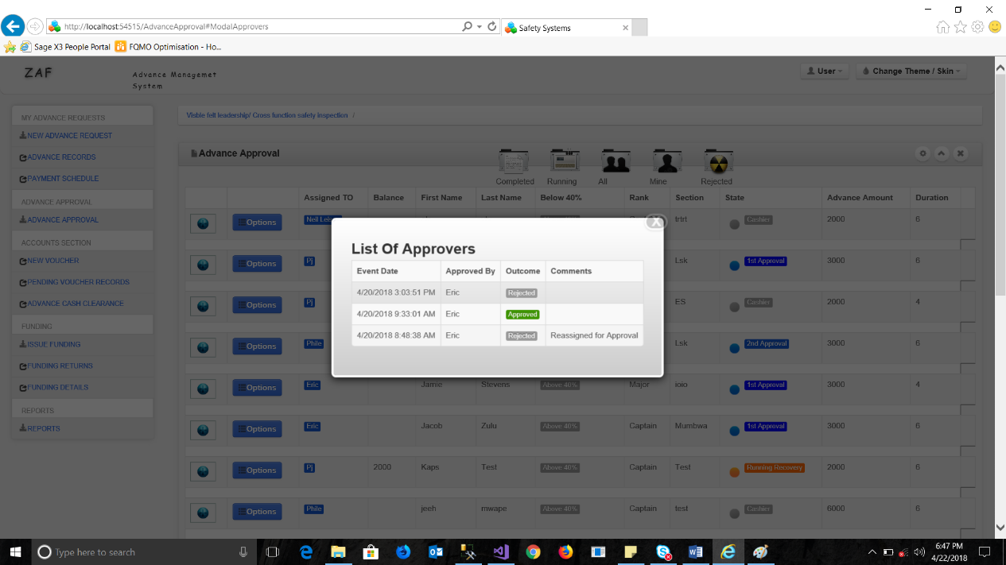

## The Approve button

The approve button is only available for the individual assigned to, hence this control or option is not visible to anyone else, though one would have to reassign it to themselves or to the desired participant to make it valid for another person to approve.

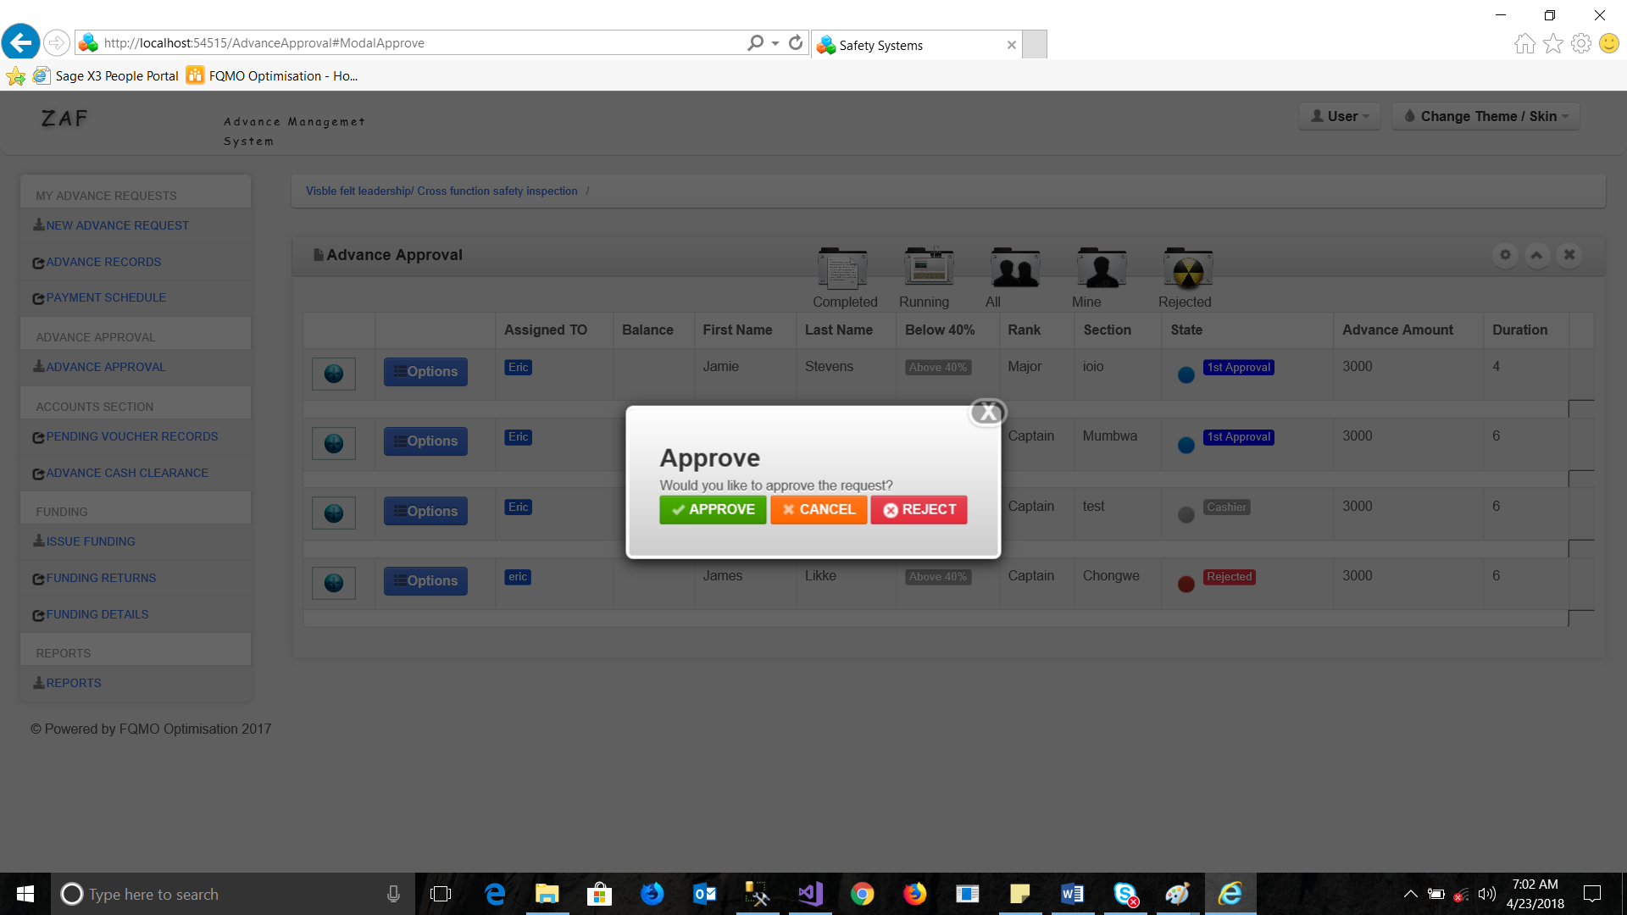

Once approved the form updates its level and redirects to the next participant.

## The Rejection form

This form is visible upon selecting reject from the previous window,

The rejection may be sent with rejection remarks so as to aid the previous participant know why the form has been rejected.

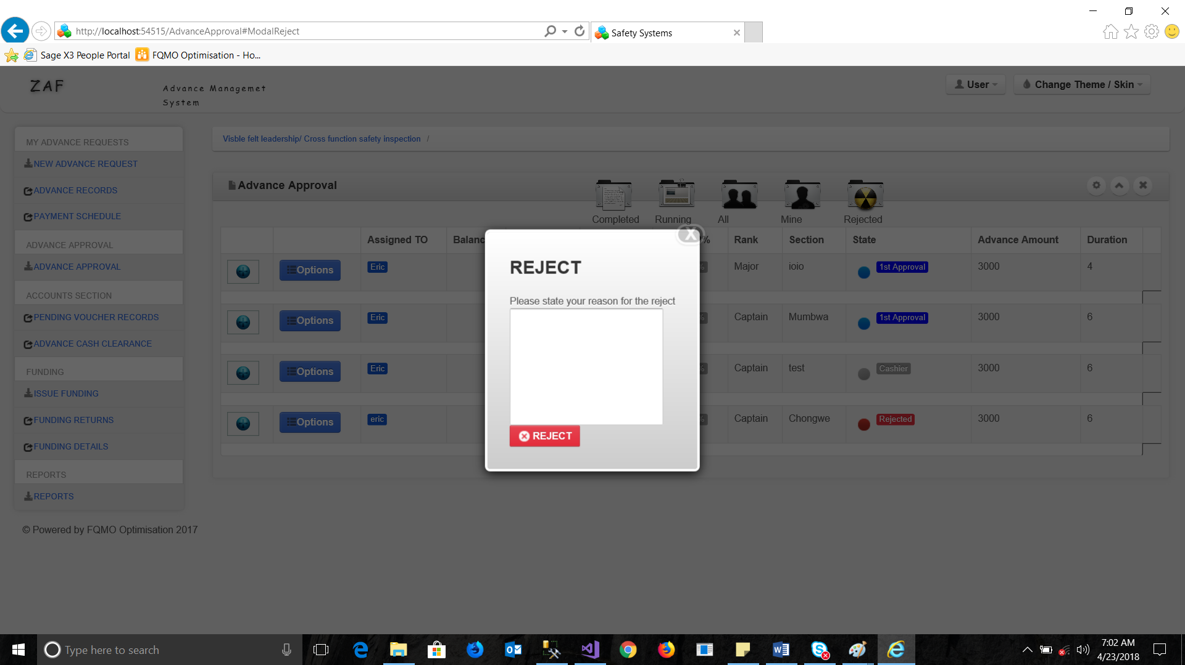

## The Pay slips option

This option when clicked displays the window with download pays lips options,

This control allows the viewer to download and view a copy of the attached pay slip from the participant.

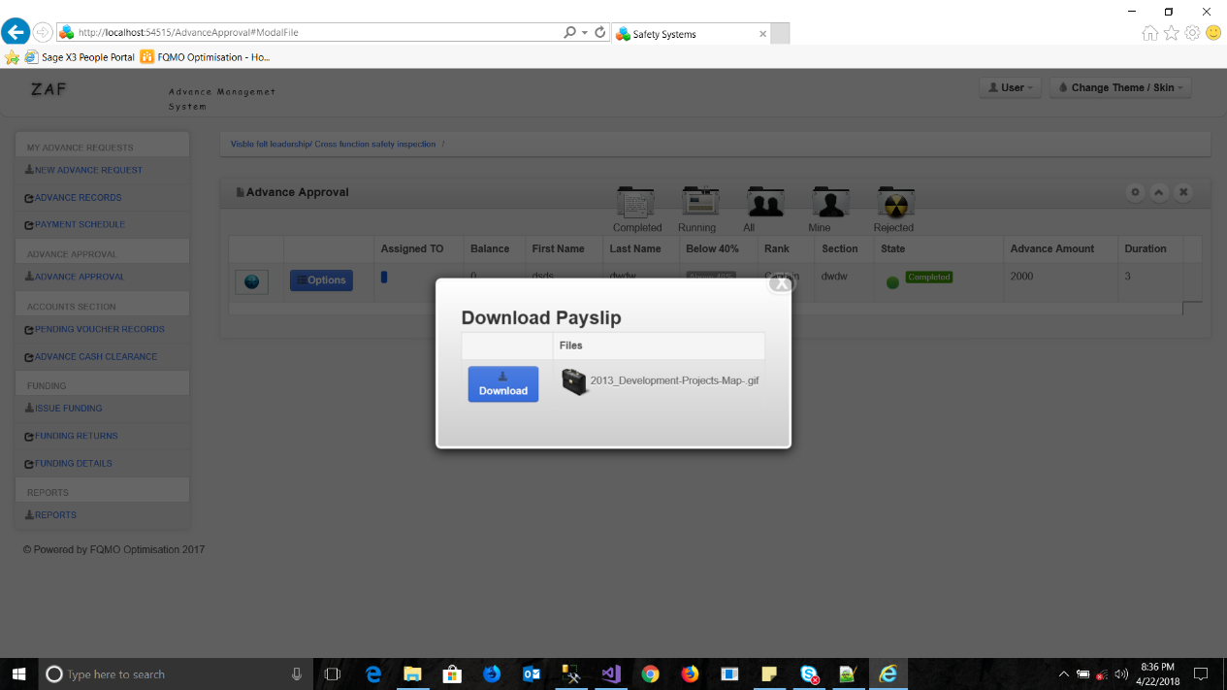

## Payment schedule calendar

This controls provides a calendar with filtered options of how the entire workflow has been running, with accurate timelines of when deductions, submissions, approvals where done for that particular entry.

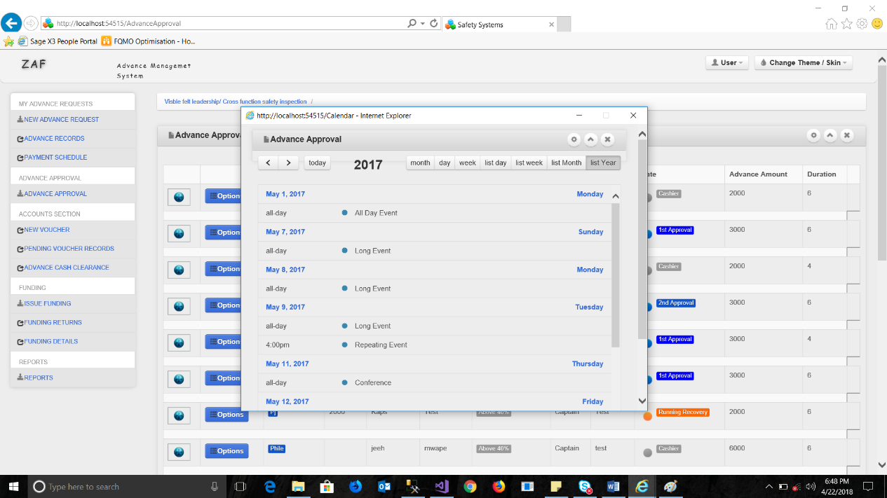

There various controls associated with the calendar, the calendar can be used to view yearly, Monthly, weekly and daily events both as list events or as time lined events.

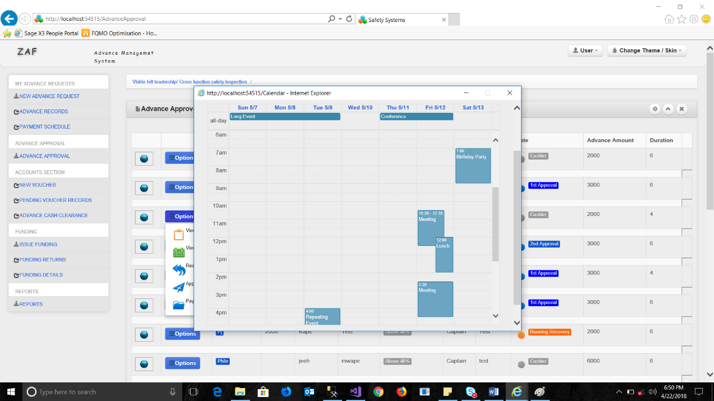

# Cashier Workflow

The cashier workflow, this is the final workflow, its accessible only by the cashier of the advance, the workflow is only triggered after the previous two stages have n=been completed in the system.

There are three filters associate with this section.

**Running**, **Pending** and **Completed,** the running filter, loads only advances that are currently undergoing deductions.

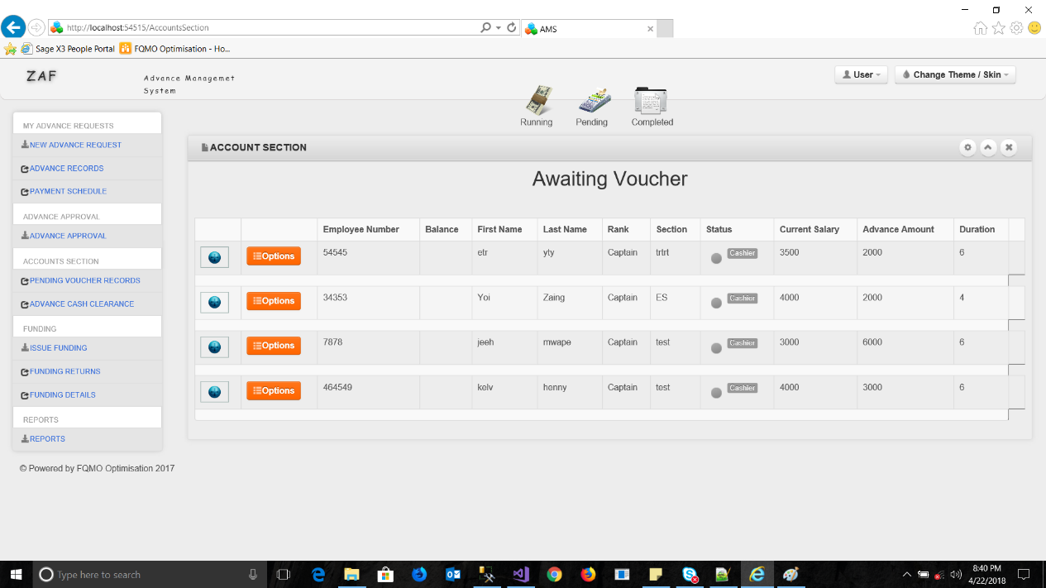

The **Running** workflows are indicated with an orange icon and label, these have the options on rendering a voucher previously submitted.

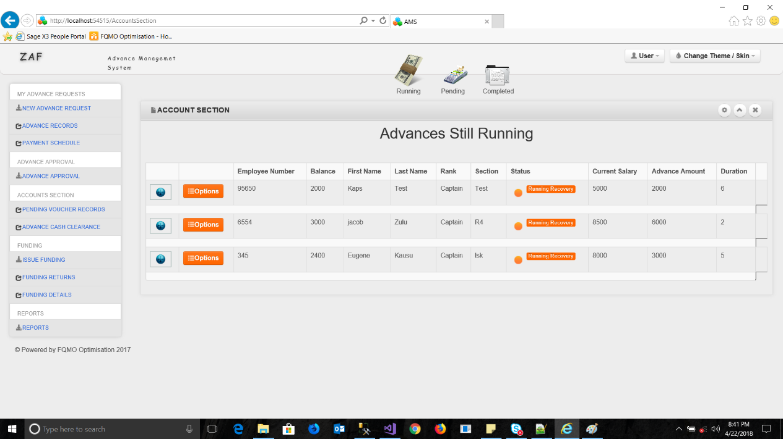

Upon clicking the options button colored orange, the submenu appears with the following buttons.

**View approvers, New voucher** and **Attach documents**.

The view approvers button displays the list of approvers.

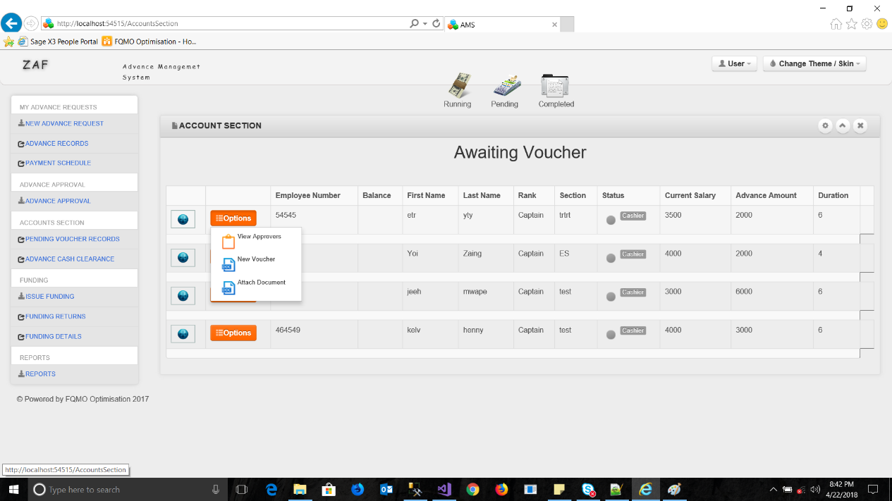

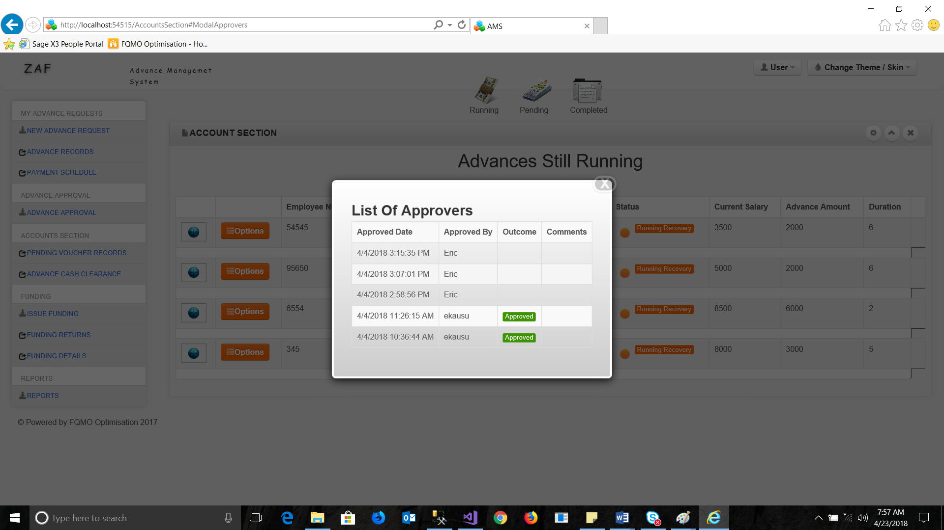

## The New Voucher Button

Once clicked this control generates a voucher input form, the voucher input form, holds all the basics for creating a voucher.

The voucher input form once completed and submitted renders the voucher that can be printed.

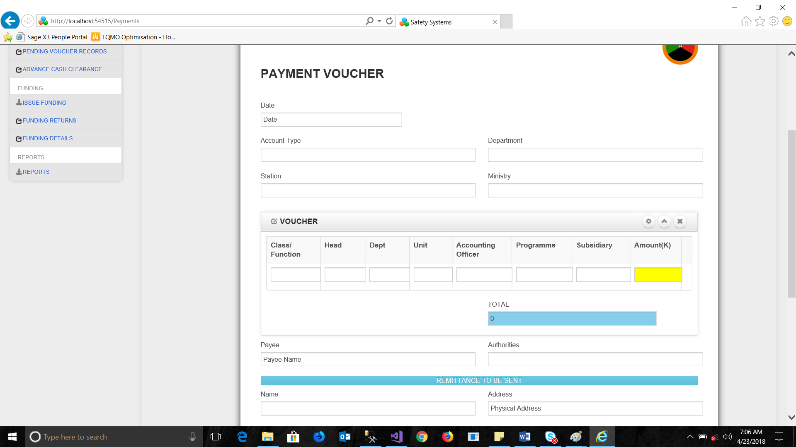

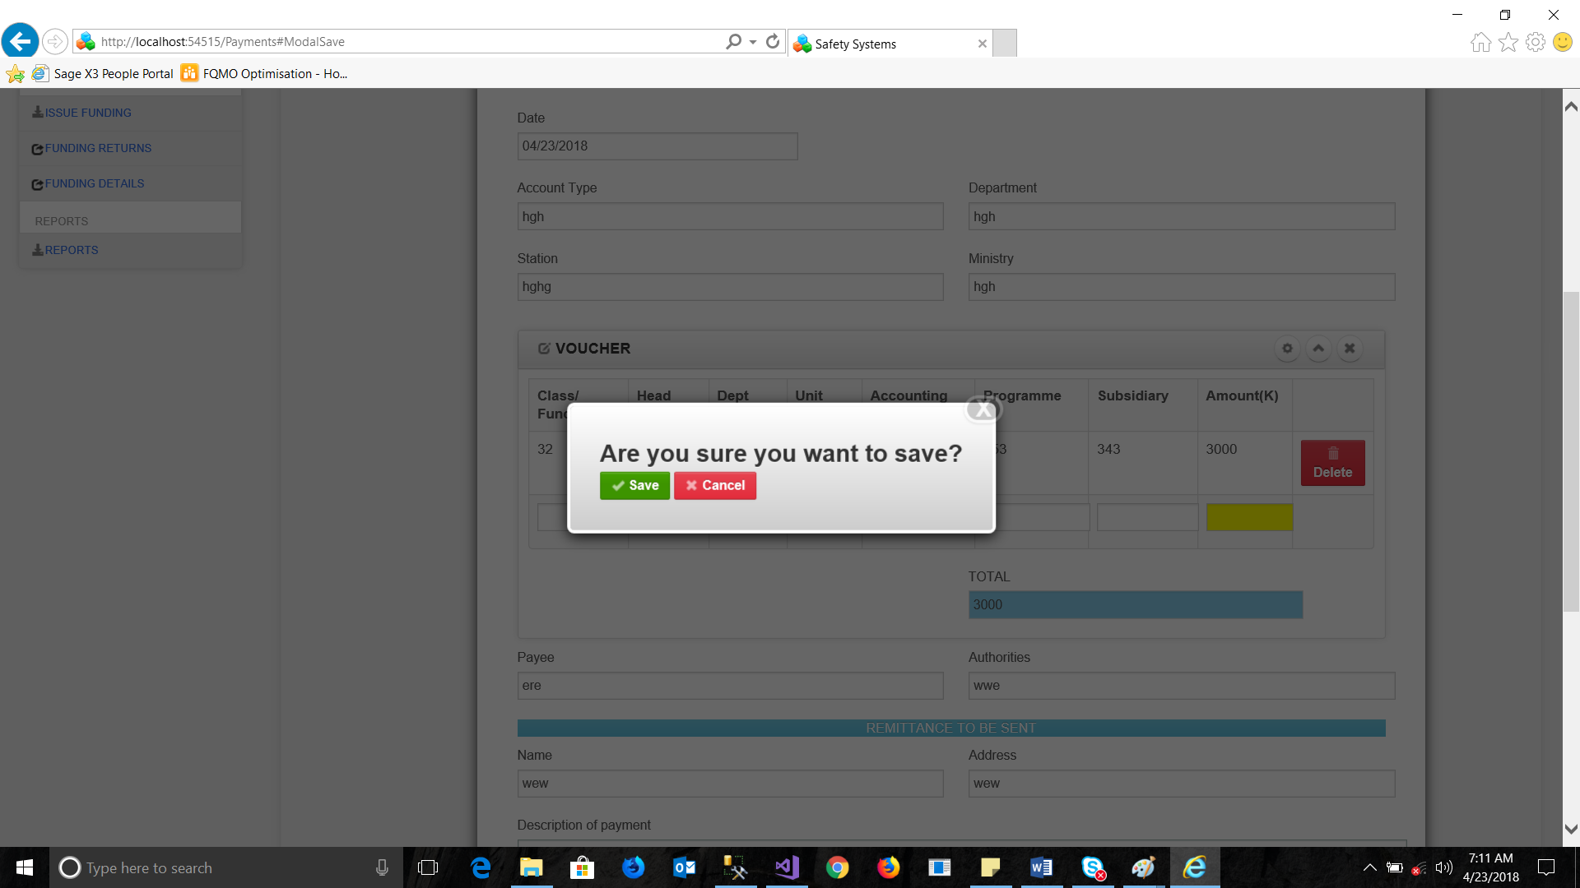

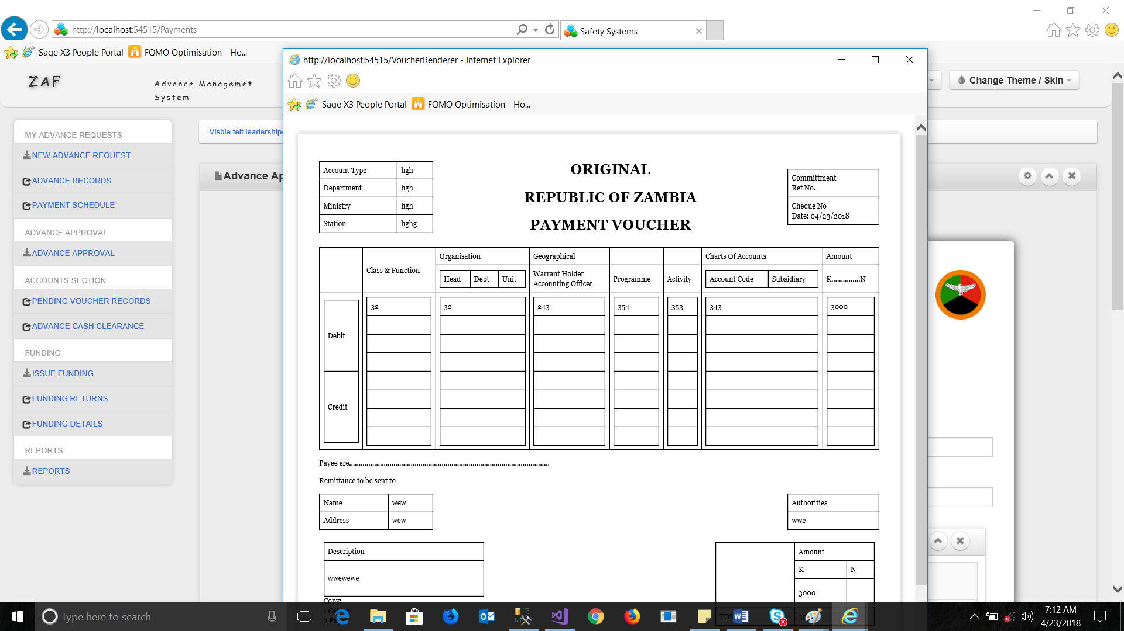

The payment voucher is rendered on a printable printer control, in order to print, simply right mouse click on the form and select print or print prview.

The print preview option displays the form as shown below. The voucher in this state can be printed

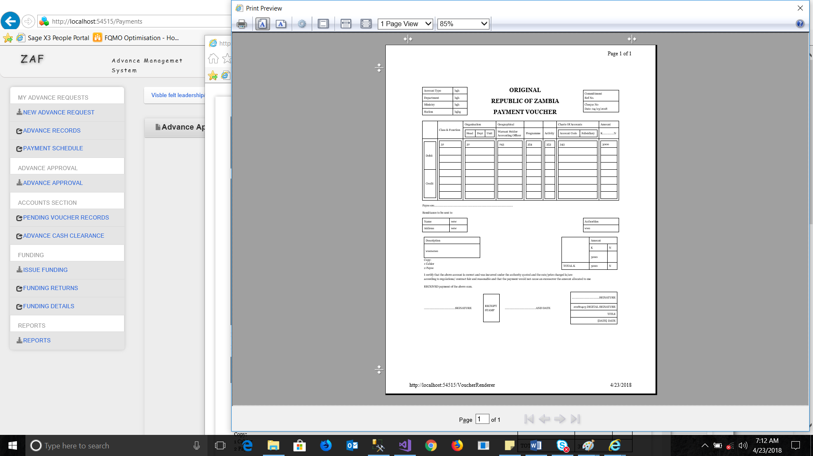

Once completed the system that initiates the advance request as complete and triggers the auto deduction mechanism as per month of that particular request. The deductions are done as per the date of creating or completing the advance request in a period of 30 days(Month)

## Running and Completed Advances

Any advance that has been started provides extra options to the cashier, the advance record can be cleared by cash thus reducing the priod in which it will be completed.

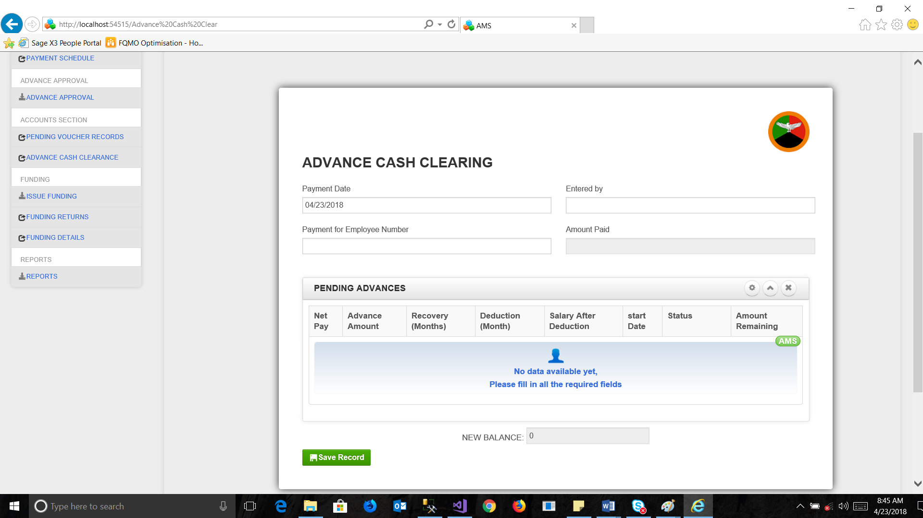

The advance clearance form, this works by placing the employee number first on the form to display their pending advance details. This information can be viewed as shown below, the form only allows payments of the exact same amount remaining as balance.

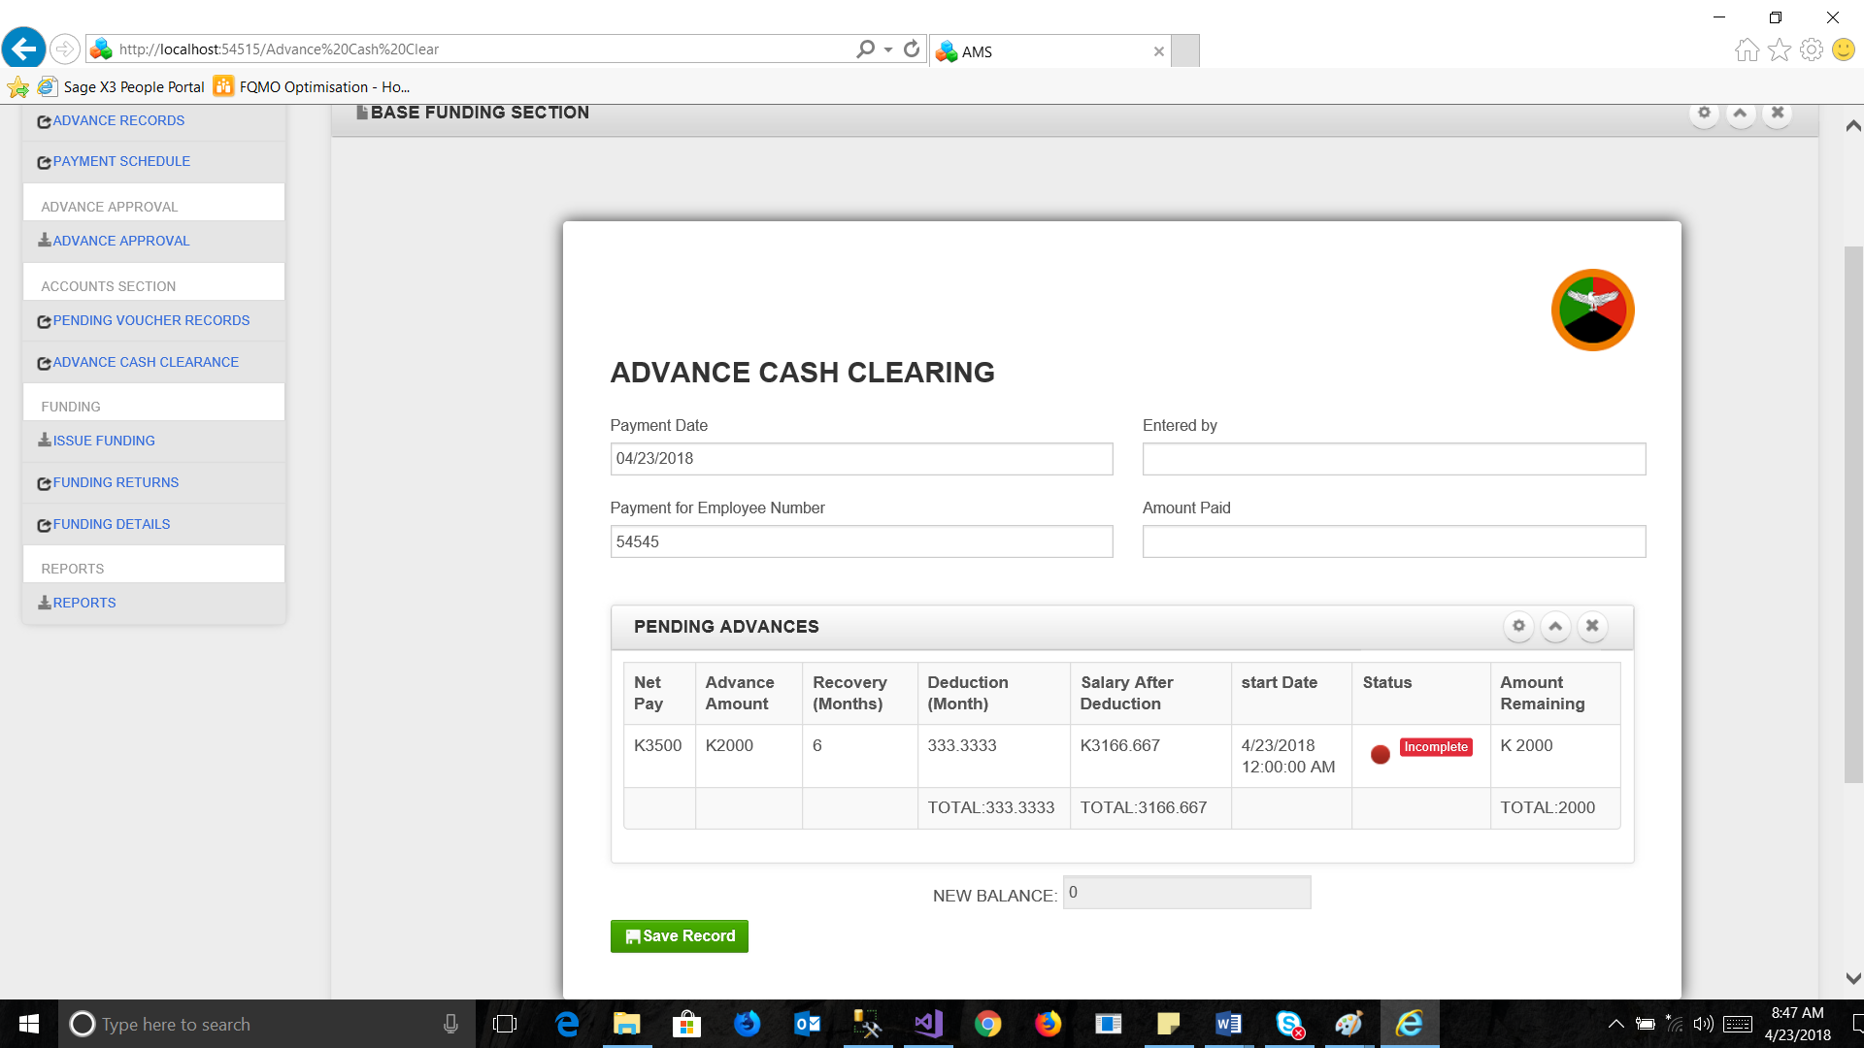

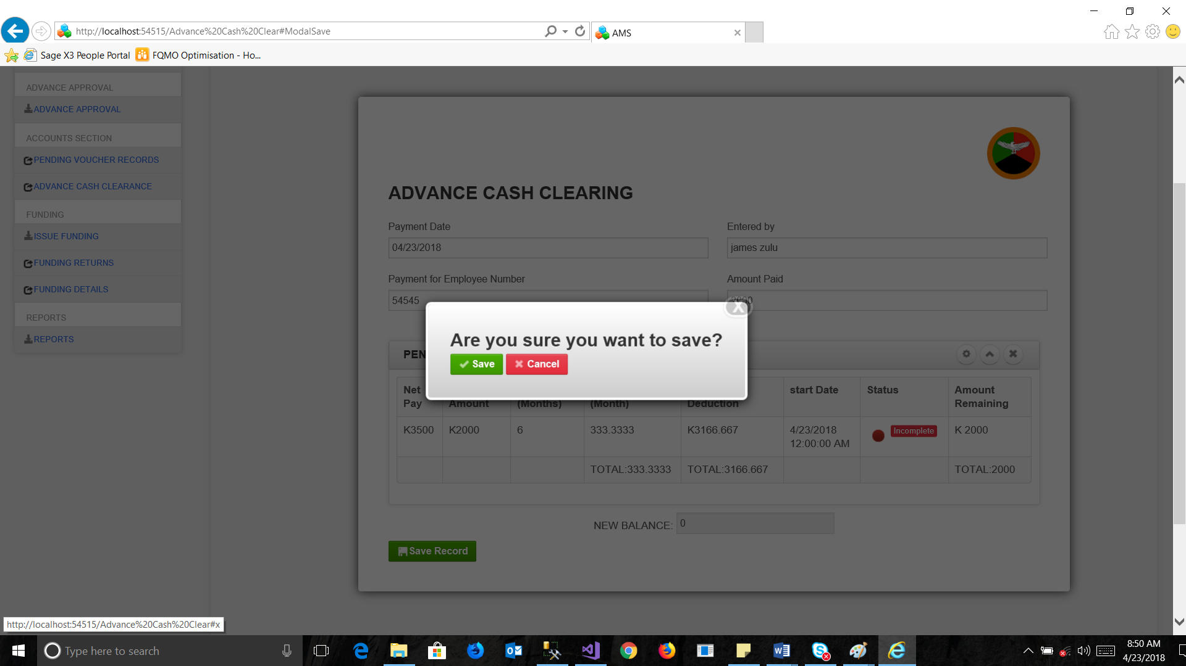

Upon clicking save if all entries are correct the system, provides the save option.

Any amount greater than the balance prompts with an error

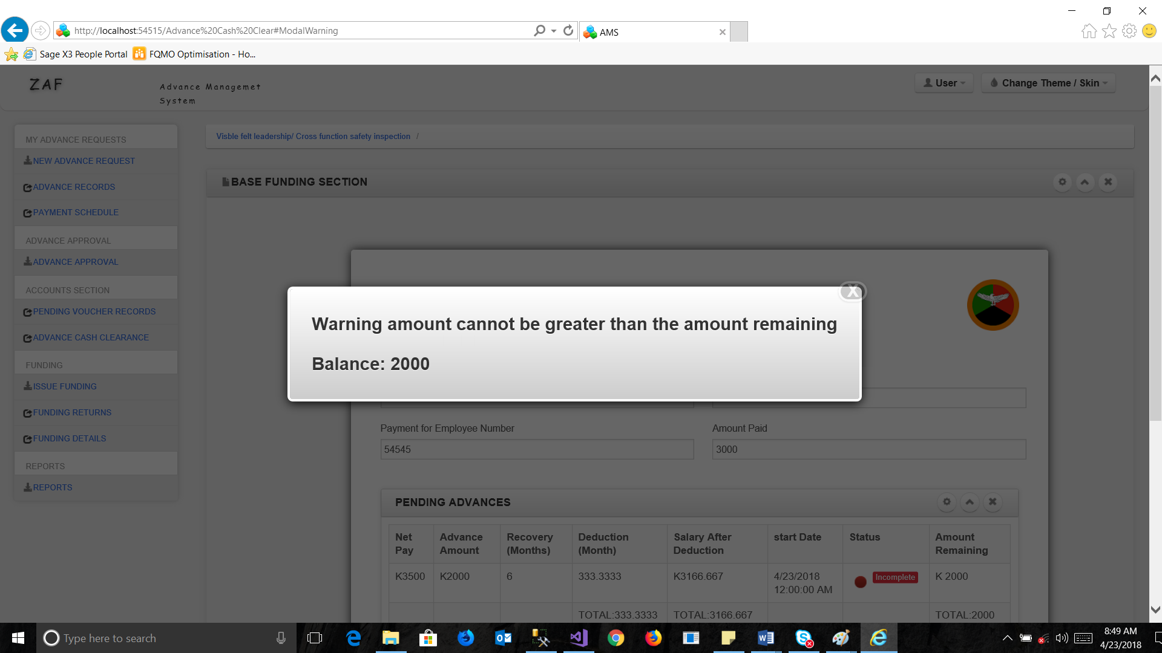

# MULTI FUNDING

The new funding form, this form is used for allocation funding to stations in a selected period of time, the form auto monitors the previous balances from previous entries.

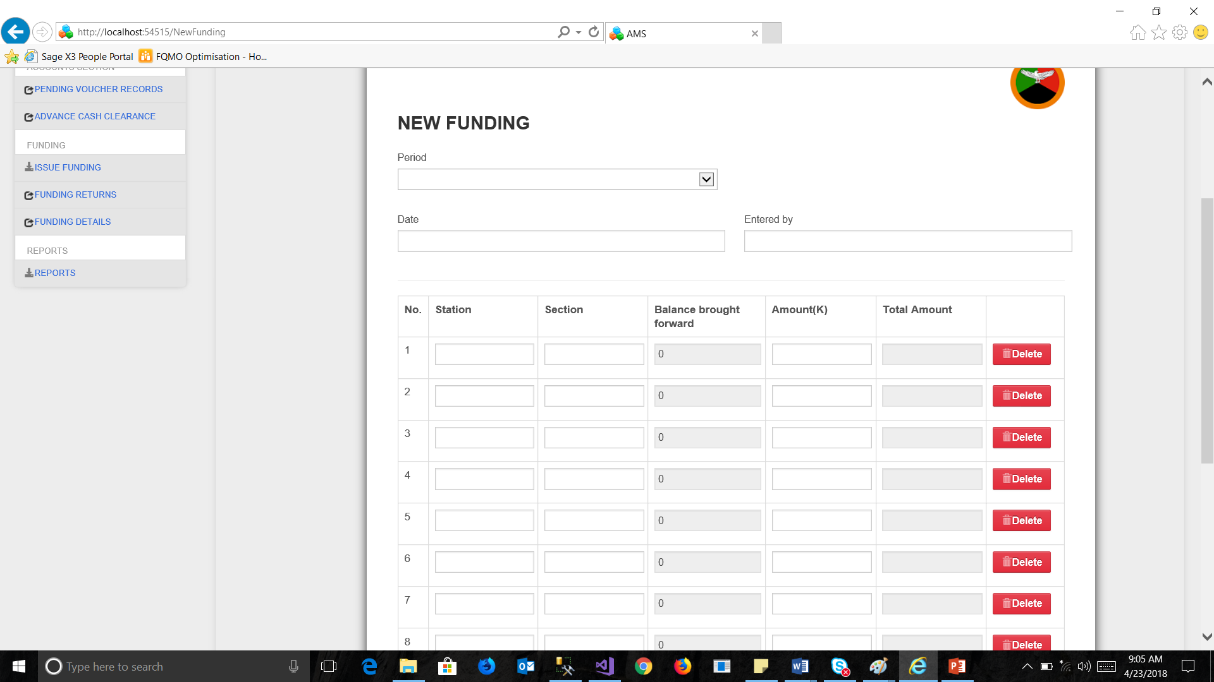

In order to fill in the form, the user must provide a summary of the entry at the top, and each entry auto calculates the total funding been generated.

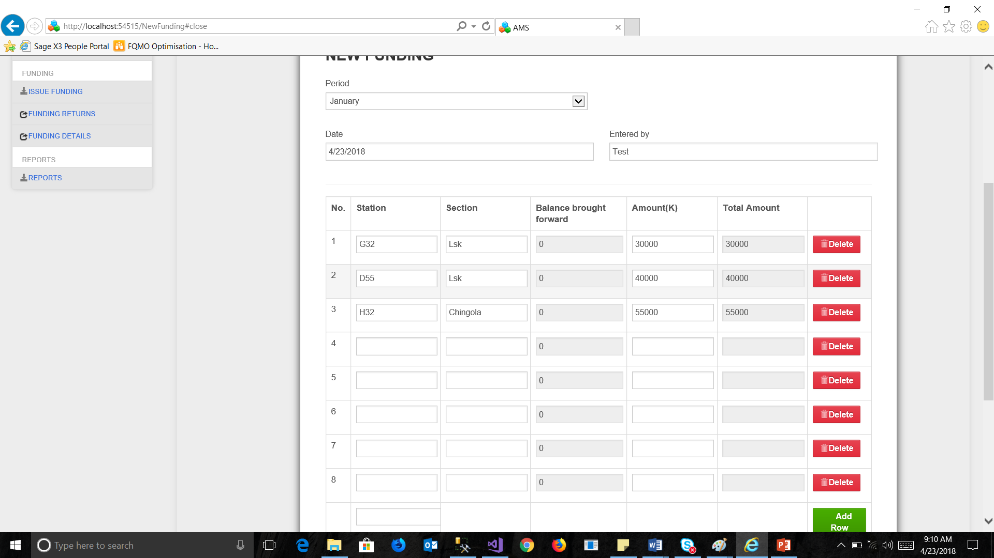

Upon entering each entry, the form auto calculates, and each entry is marked with a delete option on its right.

In order to delete an entry simply, select the delete button the right and the entry automatically is deleted.

The save button displays the save message box, select save to save the entries.

After saving the system, refreshes itself and empties all entry fields.

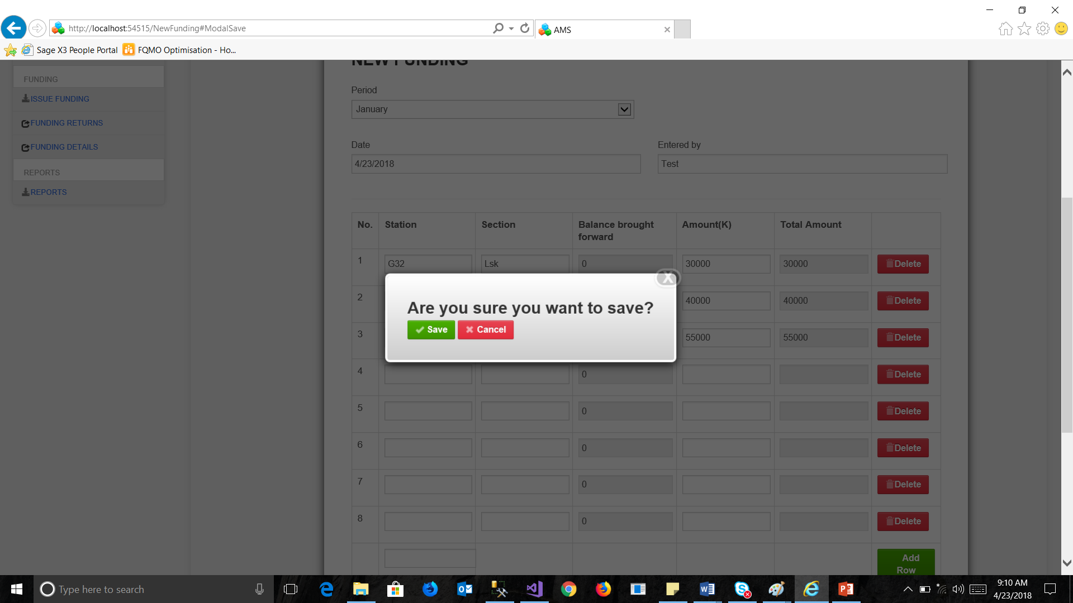

# TABLE OF DEFINATIONS

|  |  |
| --- | --- |
| TERMS | MEANING |
| AMS | Advance management system. |
| User access | Access levels for system |
| First approver | First application verifier |
| SECOND APPROVER | Second application verifier |
| File Number | Unique file number assigned to employee |
| Data viewer | Section that displays employee information |
| Request ADVANCE | Advance workflow initiation |
| Reject | Rejected advance requets |
|  |  |